

GIS Library Tutorials – Introduction to ArcGIS Online - 3

Download your data from the National Parks & Wildlife Service website

To get started, download the GIS layers (also known as shapefiles) to your computer by clicking here: www.npws.ie/maps-and-data/habitat-and-species-data

You should now be on the NPWS website – left click on the Download link for Ancient and Long-Established Woodland

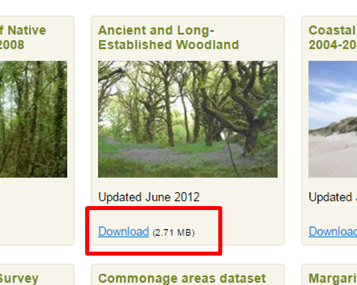



At the bottom left of your screen look for the file which ends with .zip and left click on this –
a new folder will be created containing the zipped files

You should find this folder ‘ancient-long-established-woodland’ located in your Downloads folder on your PC or laptop

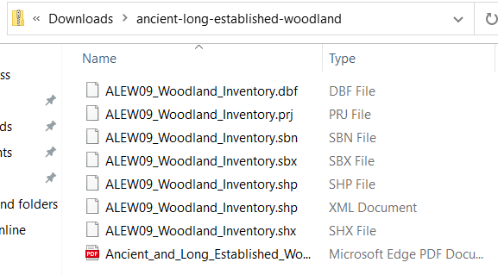

In ArcGIS, GIS layers are commonly known as shapefiles. This is a spatial data file format which can be read in GIS programmes.

The shapefiles contain maps and data which you will need for the exercise. Note that the files are zipped (i.e., compressed into a single folder).

In ArcGIS Online the shapefile needs to be uploaded within its zipped folder to be read correctly. A shapefile (singular) consists of several different files – they have the same name but each with a different file extension, as you can see from the file above.

Now you have your digital data ready in a folder which can be imported into the ArcGIS Online map you are creating

